Nita Jonuzi

GBI Case Study #1

Jerad Lumina

1.1                 Display Current is representative of the current state of the material. The Display at Key Date requires the user to insert a key date and the material number.

2.1 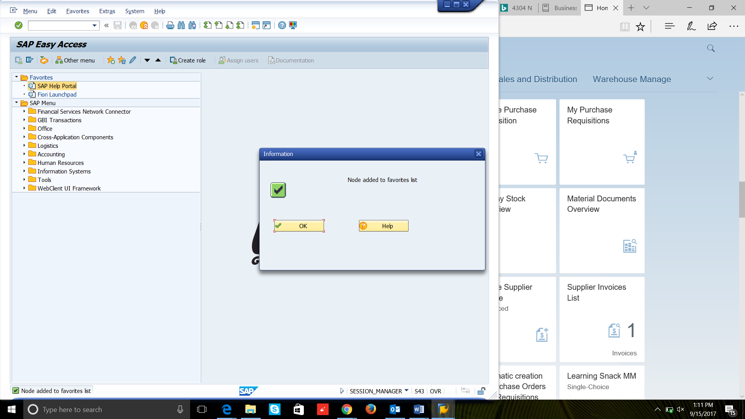

2.2

3.1          Display Sales Document

3.2          XD03 – Complete

3.3          The difference between VD03 (Sales and Distribution) and XD03 (Complete) is that the XD03 completely displays the total customer transactions.

3.4          VL01N: Create Outbound Delivery

                MM02: Change Material (Initial Screen)

                ME23N: Display Purchase Order

4.1          a) Back b) Continue (Enter)

4.2          The save button is grayed out because there is nothing to save because no work has been done yet.

4.3          A

4.4          a) Exit leaves that execution and goes to the initial screen.

                b) Stops the current processing and goes to the initial screen.

5.1          A distribution channel is the way the business reaches the customer.

5.2          a) SO is rush order

                b) OR is Standard Order

5.3          Rush order means that the delivery is created as soon as you save the sales order.

6.1 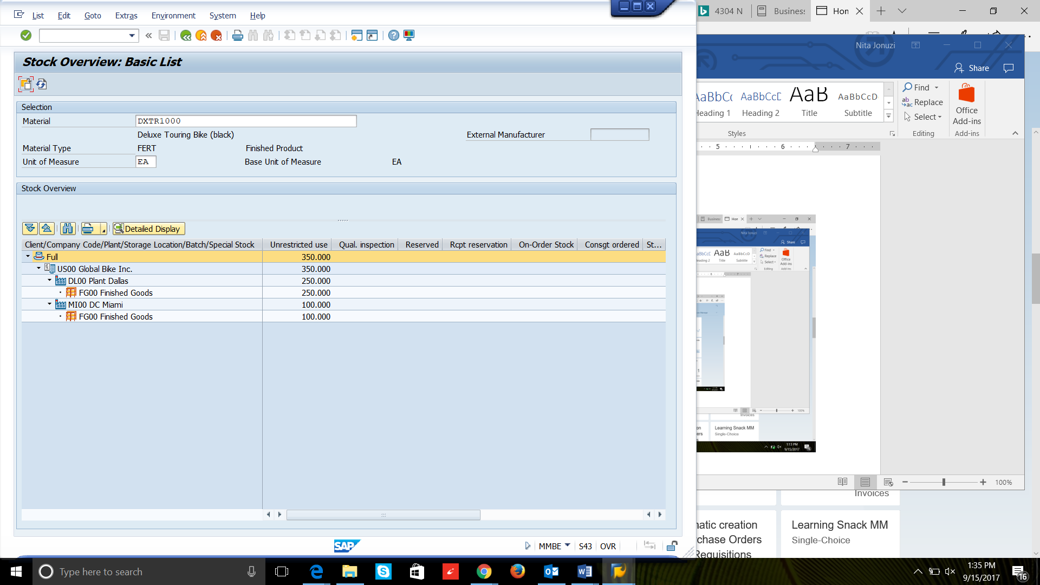

 8.1 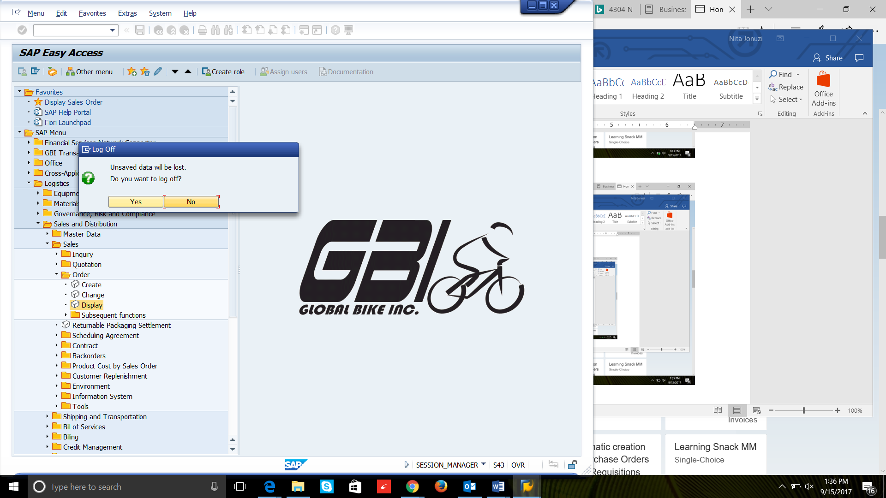

SAP Fiori

SAP Fiori

Step 3:

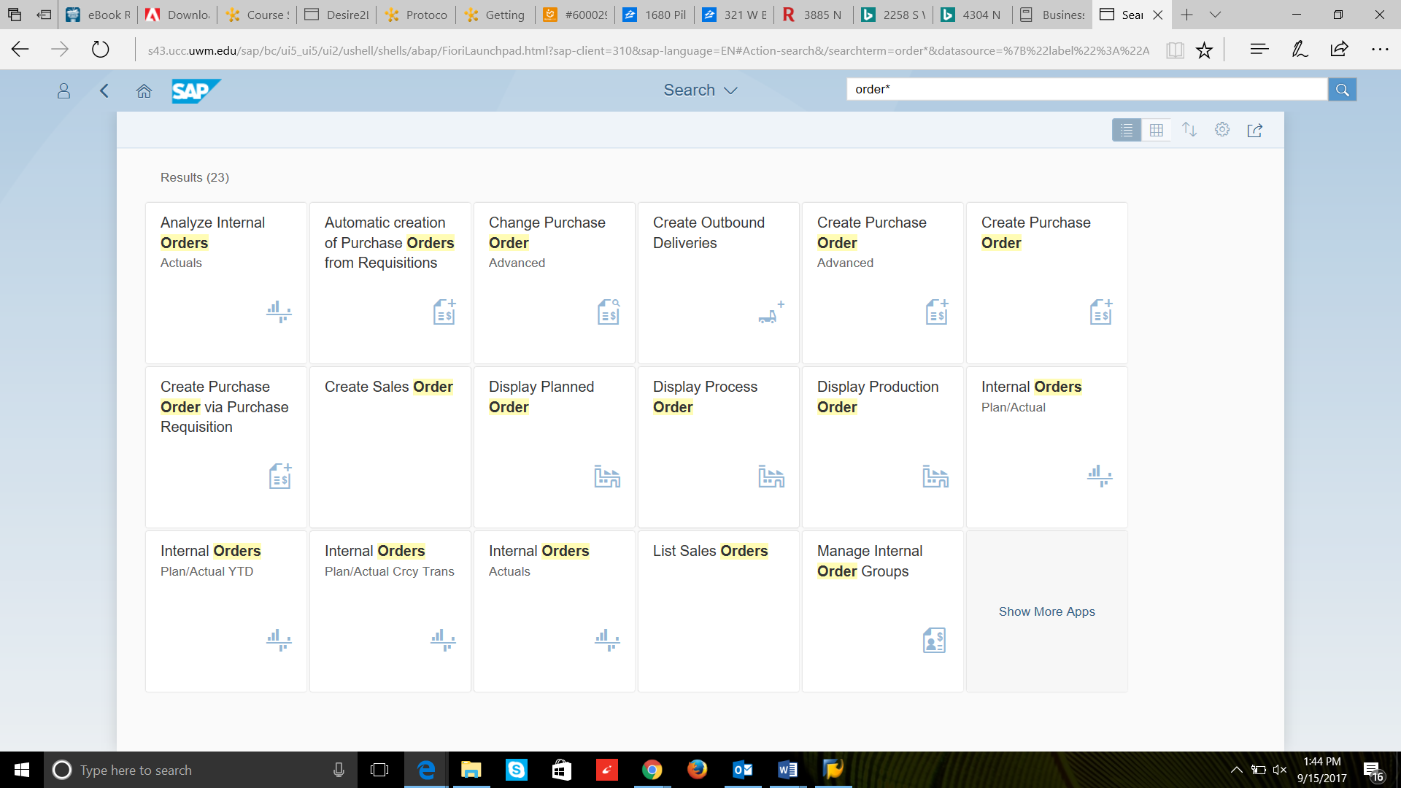

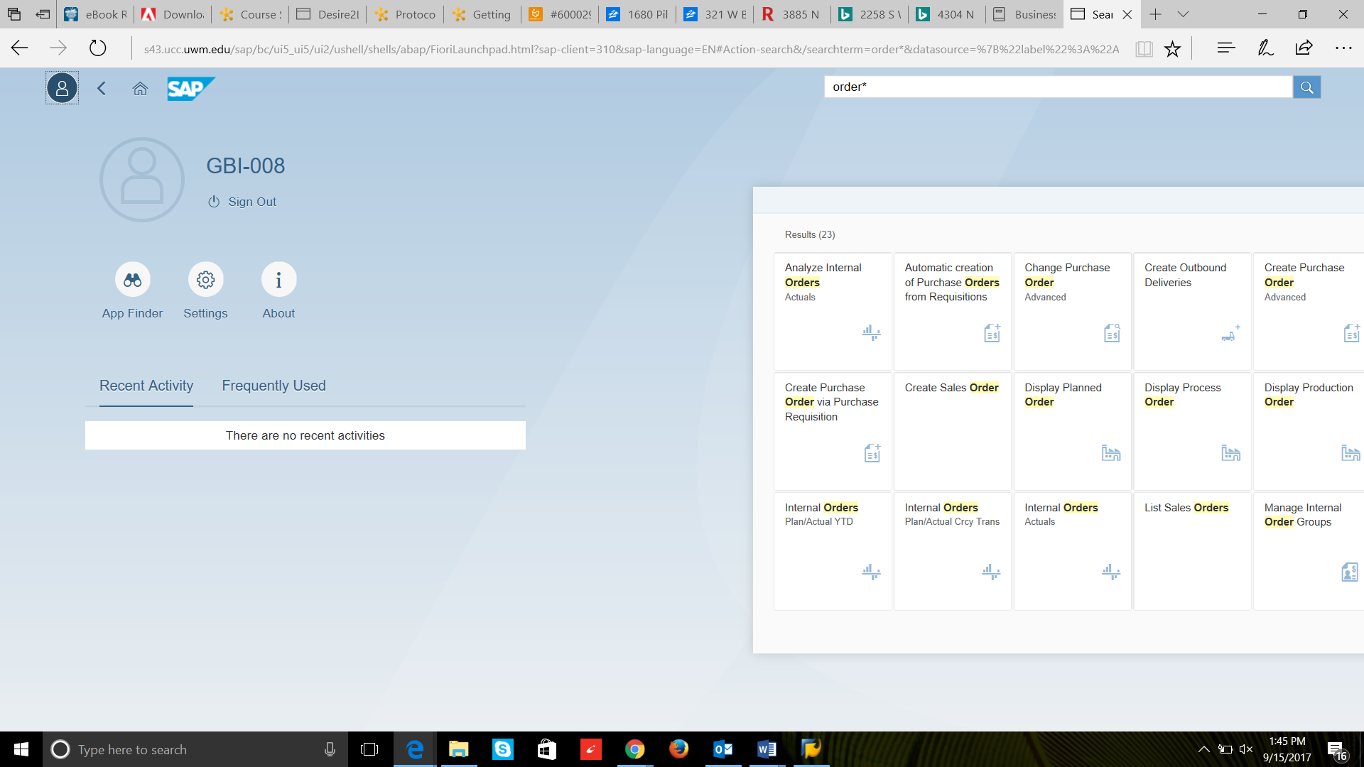

Task 4:

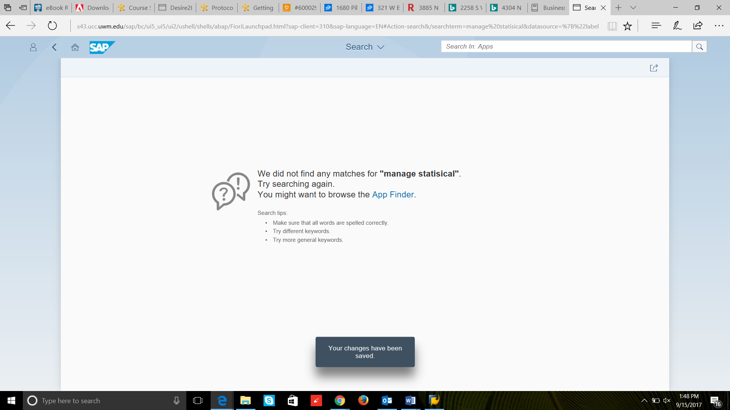

Task 4: 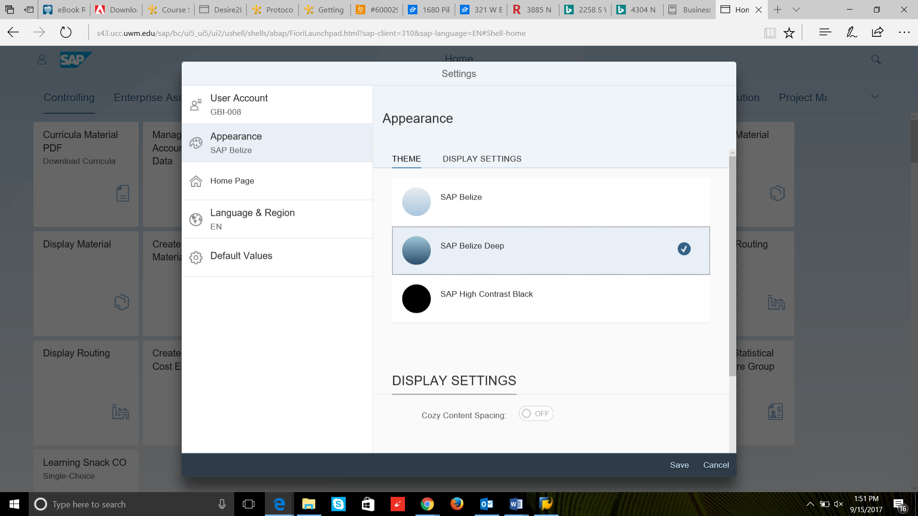

Task 5:

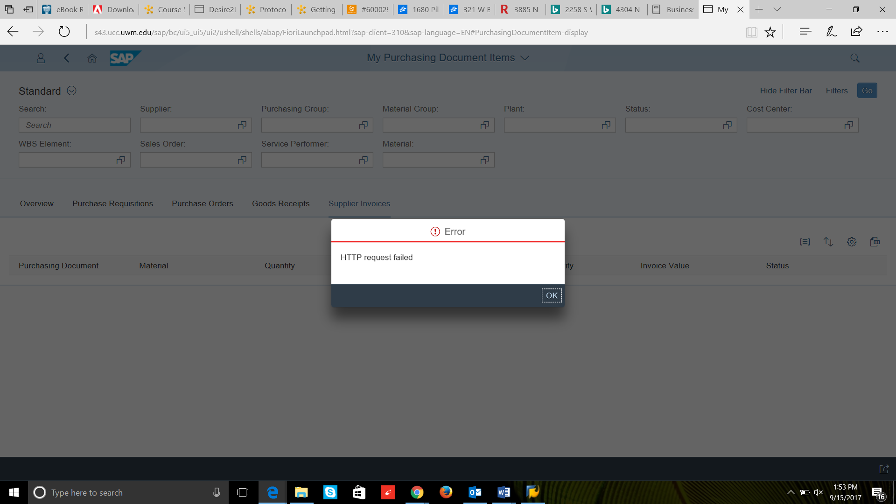

Task 6:

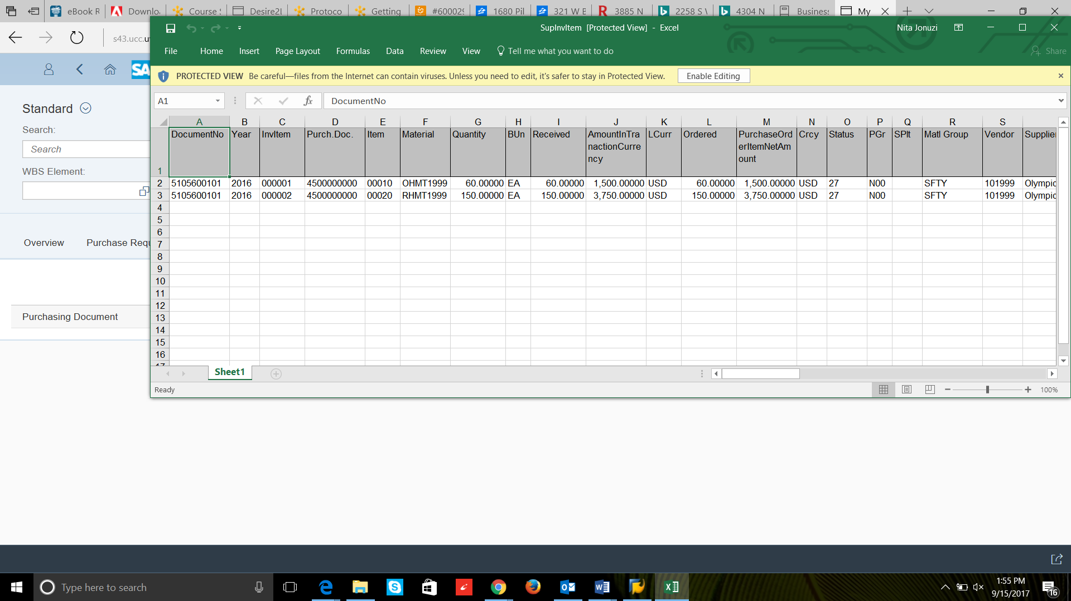

Task 6:

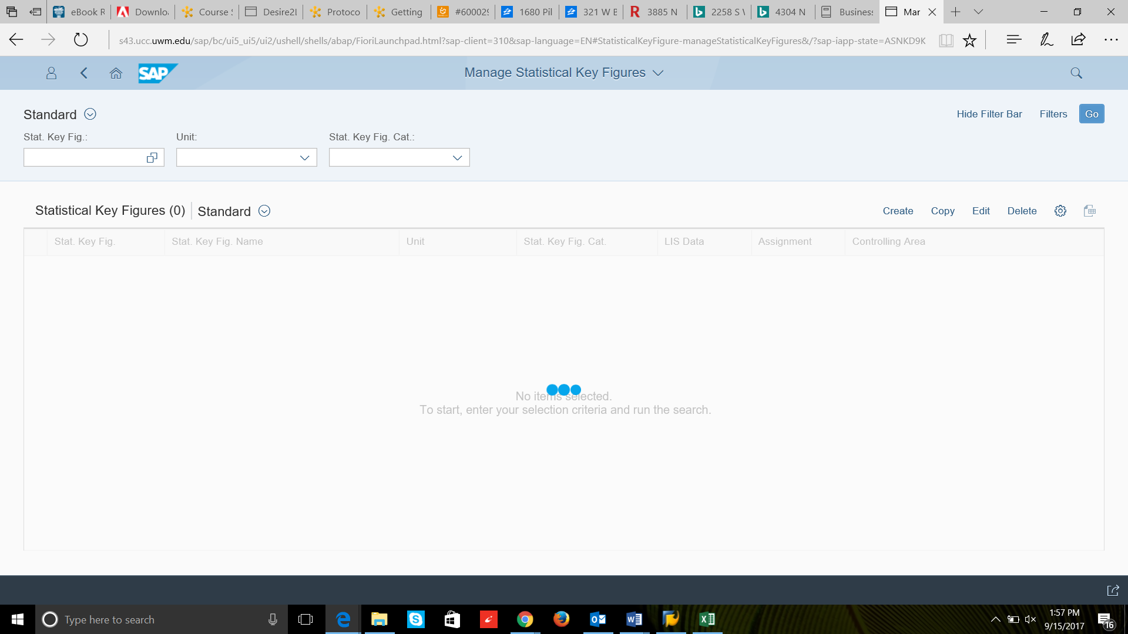

Task 7: 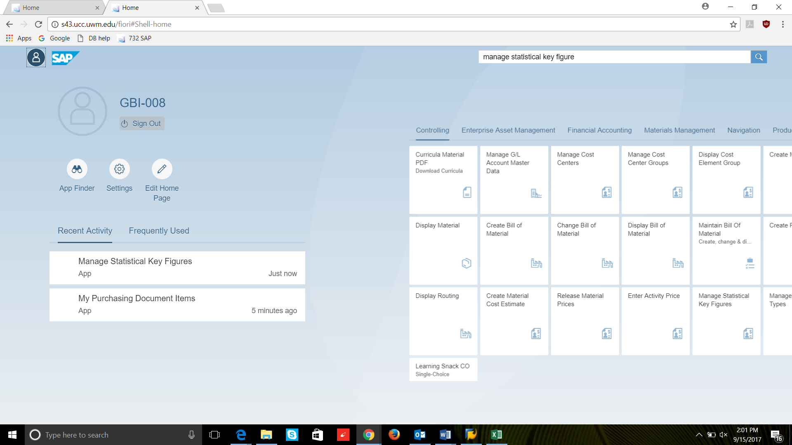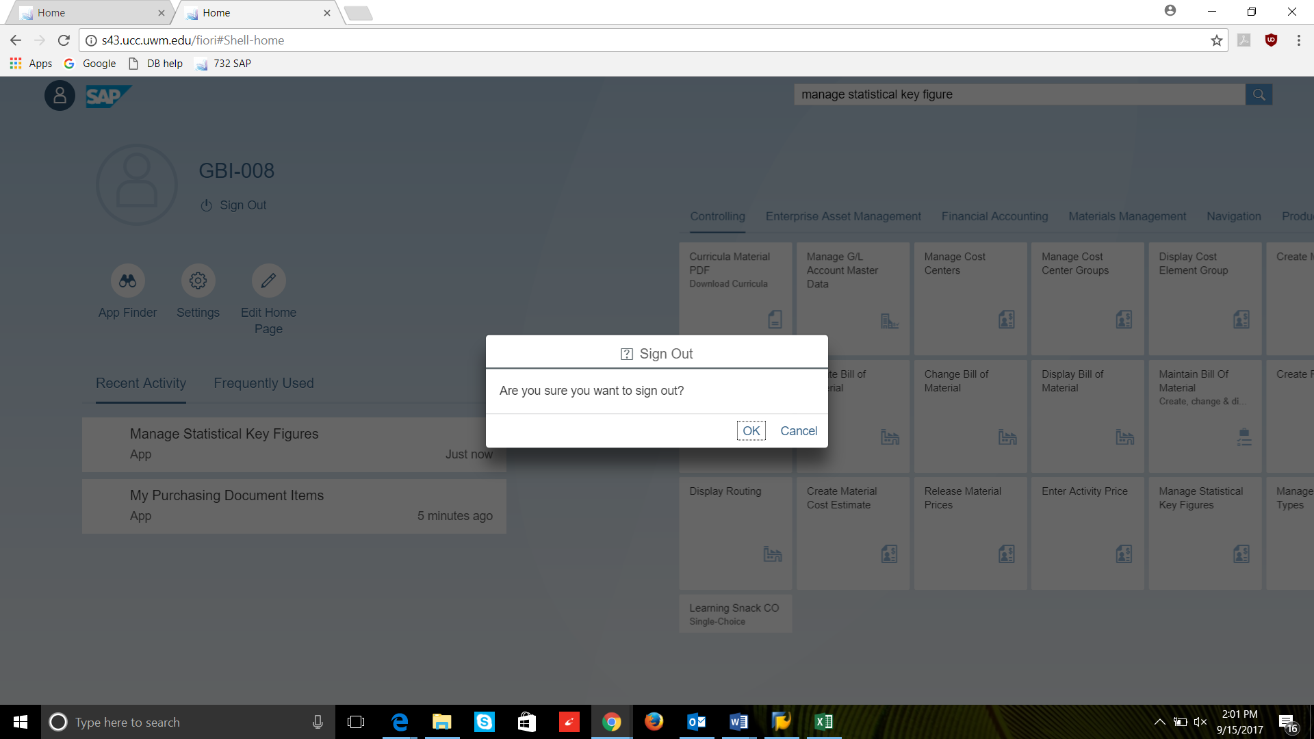

Case Study Question:

A reason why people may choose Fiori instead of the SAPGUI is that Fiori has a cleaner, more simple visual approach. This makes it more likely for clients to utilze.